Setting up the Development Environment
For the Tawala Desktop Applications
Updated 3/12/2008 11:10:00 PM

Overview
Four major components are required access the source code for the Tawala desktop applications (and related tests suites), and to build them.

- Visual Studio .NET 2008 and the MSDN Library

- Source Off Site - Version 4.2 (or Version 4.1.2)

- TX Text Control .NET – Version 12.0, Service Pack 2

- NUnit - Version 2.4.3

Visual Studio .NET 2008 Setup
Use the “Custom” installation, and select the following options (next three screen shots):
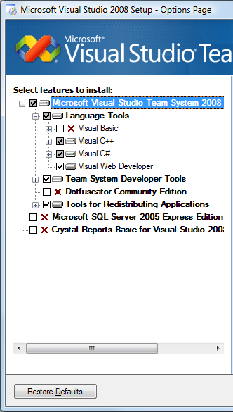
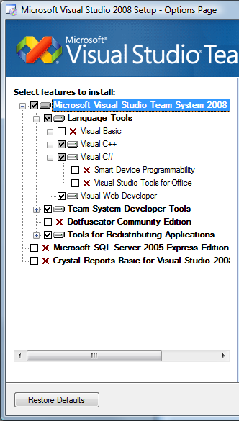
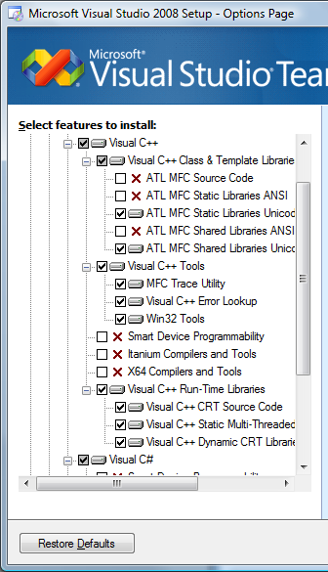

Installation of Visual C++ is not necessary, but I would at least install everything in the subsection called “Visual C++ Run-Time Libraries”.

MSDN Library Setup

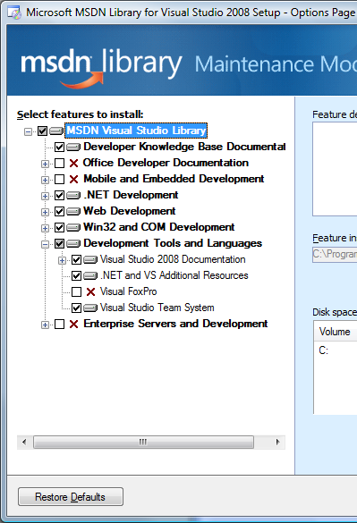

By doing a custom MSDN installation like above, you not only cut down on disk space used, but also reduce the amount of extraneous references / documentation.

Source Off Site Installation and Setup

- Go to http://www.sourcegear.com/sos/downloads.html and download the SOS Client version for Windows. Get the one with 128-bit encryption. Either Version 4.2 or 4.1.2 will work with our Source Safe repository.

- Install SOS on your system.

- Run SOS. You will be prompted for username and password. Use the credentials that you have been assigned for accessing John F’s development server (www.jdftech.com).

- If you are not automatically prompted for a server, select Connect to Server… from the File menu. Enter www.jdftech.com for the server and port 8080.

- From the File menu select Set Working Folder… and choose the target location on your system for the source code files.

- Do a recursive Get Latest Version… to fetch everything from the root ($/) level. (Note: you may want to “cloak” certain projects to reduce the size and time of the “get.” Talk to one of the other developers for help on this.)

TX Text Control .NET Installation

- You should already have installed Source Off Site and done a recursive “get” of the entire Tawala repository. This will include the Third Party folder.

- Under the Third Party folder there is a TX Text Control folder. Run Setup.exe from that folder to install TX Text Control .NET Version 12.0 on your system. (Note: This installation includes Service Pack 2.)

As part of the installation you will be prompted for a serial number. The currently assigned serial numbers can be found in the _Developer Serial Numbers.txt file in the same folder.

- Important: After the installation is complete, find the following file under the installed TX folders:

Filename: txtextcontrol12.0.msm

Likely location: C:\Program Files\The Imaging Source Europe GmbH\TX Text Control 12.0.NET\MergeModule

Copy that file to: C:\ Program Files\Common Files\Merge Modules

NUnit Installation and Setup

- You should already have installed Source Off Site and done a recursive “get” of the entire Tawala repository. This will include the Third Party folder.

- Uninstall all prior installations of NUnit using the Control Panel.

- Delete remnants of NUnit installations in the Program Files directory. Sometimes NUnit doesn’t uninstall completely.

- Under the Third Party folder there is a NUnit folder. Run NUnit-2.4.3-net-2.0.msi from that folder to install NUnit on your system.

After having built the TawalaTest solution, start NUnit 2.4.3. If all is well, the tests will load without error.

- Click the Tools | Options… menu item. Configure the Test Load tab of the NUnit Options dialog as shown below:

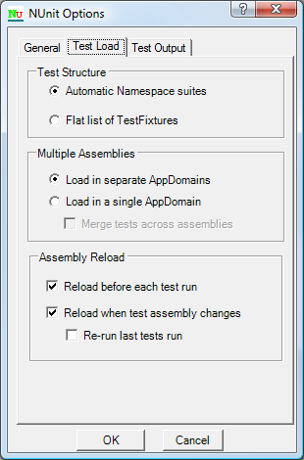

Notes:

- The Automatic Namespace suites setting is required so the [SetupFixture] attribute will work. This attribute allows a class to defined a namespace wide setup and teardown method that get executed only one time for all tests in the same namespace. This is useful for setting up Functions, for instance. This feature is being used in code checked in Sunday, August 26, 2007.

- The Load in separate AppDomains is necessary so that each Test Assembly should start with a “clean slate!”

This section isn’t required reading. However, if you want to have an inkling of why using this setting is a good idea, then proceed.

This setting is required so that tests in different assemblies have no chance of affecting each other. Otherwise static constructors are called only once and static variable are initialized only once during a test run. Test assemblies farther down the chain are left with whatever legacy that came before them depending on test execution order, etc.

Who knows where or when this could subtly affect test results?

One current example involves Functions and the Document related factories, such as those in Paragraph.cs, that are initialized by static constructors. The problem is that Functions are also registered in those static constructors. Not all tests assemblies use the same, current version of the Function repository Xml. Some don’t need too for the type of tests they do. The Functions first registered by the static constructors in a test run win. If the next test assembly in the run rebuilds the Functions with different repository Xml, the factories in Paragraph.cs still have their prior values and are now out of sync.

It’s not really the responsibility of the app to support quirks of the test environment. So we must use Load in separate AppDomains.

